**JAVA STRINGS ASSIGNMENT 3**

1.) import java.util.Scanner;

public class Main

{

public static void main(String[] args) {

String s;

int n;

Scanner ob = new Scanner(System.in);

System.out.println("Enter the string : ");

s=ob.next();

System.out.println("Enter the index number : ");

n=ob.nextInt();

int i = s.charAt(n-1);

System.out.println("The character at "+n+" index is "+ (char)i);

}

}

Output:

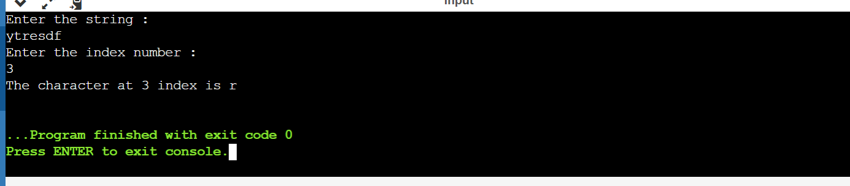

2.) import java.util.Scanner;

public class Main

{

public static void main(String[] args) {

String s1,s2;

Scanner ob = new Scanner(System.in);

System.out.println("Enter the first string : ");

s1=ob.next();

System.out.println("Enter the second string : ");

s2=ob.next();

int result = s1.compareTo(s2);

if(result<0)

System.out.println(s1+" is less than "+s2);

else if(result==0)

System.out.println(s1+" is equal to "+s2);

else

System.out.println(s1+" is greater than "+s2);

}

}

Output:

3.) import java.util.Scanner;

public class Main

{

public static void main(String[] args) {

String s1,s2;

Scanner ob = new Scanner(System.in);

System.out.println("Enter the first string : ");

s1=ob.next();

System.out.println("Enter the second string : ");

s2=ob.next();

int result = s1.compareToIgnoreCase(s2);

if(result<0)

System.out.println(s1+" is less than "+s2);

else if(result==0)

System.out.println(s1+" is equal to "+s2);

else

System.out.println(s1+" is greater than "+s2);

}

}

Output:

4.) import java.util.Scanner;

public class Main

{

public static void main(String[] args) {

String s1,s2,s3;

Scanner ob = new Scanner(System.in);

System.out.println("Enter the first string : ");

s1=ob.next();

System.out.println("Enter the second string : ");

s2=ob.next();

s3 = s1.concat(s2);

System.out.println("The concatenated string is "+s3);

}

}

Output:

5.) import java.util.Scanner;

public class Main

{

public static void main(String[] args) {

String s1,s2;

Scanner ob = new Scanner(System.in);

System.out.println("Enter the first string : ");

s1=ob.next();

System.out.println("Enter the second string : ");

s2=ob.next();

System.out.println(s1.contains(s2));

}

6.) import java.util.Scanner;

public class Main

{

public static void main(String[] args) {

String s1,s2;

Scanner ob = new Scanner(System.in);

System.out.println("Enter the first string : ");

s1=ob.next();

System.out.println("Enter the second string : ");

s2=ob.next();

System.out.println("Enter the sequence :");

CharSequence c =ob.next();

System.out.println("After comparing "+s1+ " and " +c+ "result is : "+s1.contentEquals(c));

System.out.println("After comparing "+s2+ " and " +c+ "result is : "+s2.contentEquals(c));

}

}

Output:

7.) import java.util.Scanner;

public class Main

{

public static void main(String[] args) {

String s1,s2;

Scanner ob = new Scanner(System.in);

System.out.println("Enter the first string : ");

s1=ob.next();

System.out.println("Enter the second string : ");

s2=ob.next();

StringBuffer s3 = new StringBuffer(s1);

System.out.println("After comparing "+s1+ " and " +s3+ "result is : "+s1.contentEquals(s3));

System.out.println("After comparing "+s2+ " and " +s3+ "result is : "+s2.contentEquals(s3));

}

}

Output:

8.) import java.util.Scanner;

public class Main

{

public static void main(String[] args) {

char[] arr = new char[] { '1', '2', '3', '4' , '5'};

String s = String.copyValueOf(arr, 1, 2);

System.out.println("result = " + s);

}

}

Output:

9.) import java.util.Scanner;

public class Main

{

public static void main(String[] args) {

String s1,s2,s3;

Scanner ob = new Scanner(System.in);

System.out.println("Enter the first string : ");

s1=ob.next();

System.out.println("Enter the second string : ");

s2=ob.next();

System.out.println("Enter the ending string : ");

s3=ob.next();

boolean e1 = s1.endsWith(s3);

boolean e2 = s2.endsWith(s3);

System.out.println("Result of 1st string ending with "+s3+" is "+e1);

System.out.println("Result of 2nd string ending with "+s3+" is "+e2);

}

}

Output:

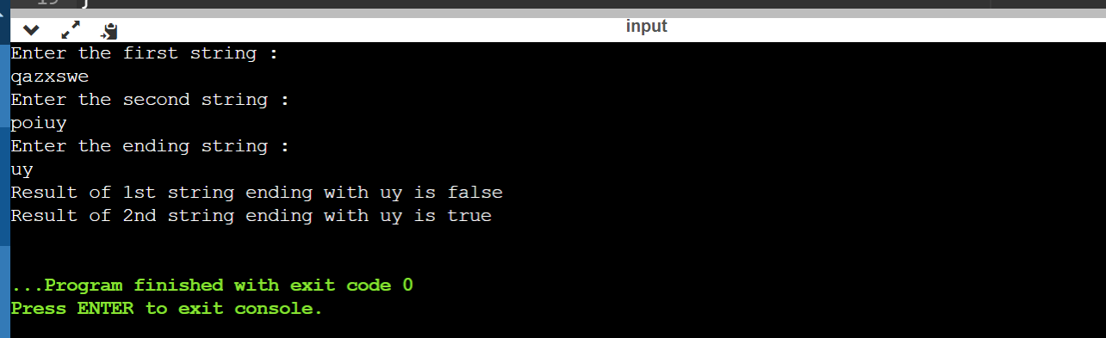

10.) import java.util.Scanner;

public class Main

{

public static void main(String[] args) {

String s1,s2,s3;

Scanner ob = new Scanner(System.in);

System.out.println("Enter the first string : ");

s1=ob.next();

System.out.println("Enter the second string : ");

s2=ob.next();

System.out.println("Enter the 3rd string : ");

s3=ob.next();

boolean e1 = s1.equals(s2);

boolean e2 = s1.equals(s3);

System.out.println("Result of "+s1+"and "+s2+" is "+e1);

System.out.println("Result of "+s1+"and "+s3+" is "+e2);

}

}

Output:

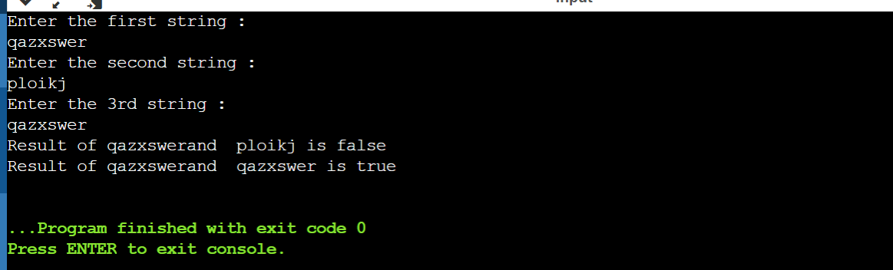

11.) import java.util.Scanner;

public class Main

{

public static void main(String[] args) {

String s1,s2,s3;

Scanner ob = new Scanner(System.in);

System.out.println("Enter the first string : ");

s1=ob.next();

System.out.println("Enter the second string : ");

s2=ob.next();

System.out.println("Enter the 3rd string : ");

s3=ob.next();

boolean e1 = s1.equalsIgnoreCase(s2);

boolean e2 = s1.equalsIgnoreCase(s3);

System.out.println("Result of "+s1+"and "+s2+" is "+e1);

System.out.println("Result of "+s1+"and "+s3+" is "+e2);

}

}

Output:

12.) import java.util.Scanner;

import java.util.Calendar;

public class Main

{

public static void main(String[] args) {

Calendar c = Calendar.getInstance();

System.out.println("Current Date and Time :");

System.out.format("%tB %te, %tY%n", c, c, c);

System.out.format("%tl:%tM %tp%n", c, c, c);

}

}

Output:

13.) import java.util.Scanner;

public class Main

{

public static void main(String[] args) {

String s;

Scanner ob = new Scanner(System.in);

System.out.println("Enter the string : ");

s = ob.next();

char[] arr = new char[] { 'a', '@', '#', 'd', 'n', '(', 'm', 'p' };

s.getChars(1, 6, arr, 2);

System.out.println("The characters array equals " +arr);

}

}

Output:

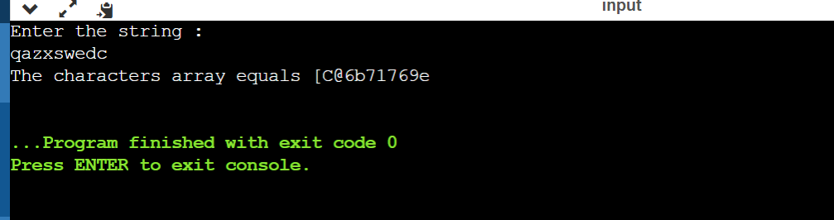

14.) import java.util.Scanner;

public class Main

{

public static void main(String[] args) {

String st;

Scanner ob = new Scanner(System.in);

System.out.println("Enter the string : ");

st = ob.next();

int a = st.lastIndexOf("a", st.length() - 1);

int b = st.lastIndexOf("b", st.length() - 1);

int c = st.lastIndexOf("c", st.length() - 1);

int d = st.lastIndexOf("d", st.length() - 1);

int e = st.lastIndexOf("e", st.length() - 1);

int f = st.lastIndexOf("f", st.length() - 1);

int g = st.lastIndexOf("g", st.length() - 1);

int h = st.lastIndexOf("h", st.length() - 1);

int i = st.lastIndexOf("i", st.length() - 1);

int j = st.lastIndexOf("j", st.length() - 1);

int k = st.lastIndexOf("k", st.length() - 1);

int l = st.lastIndexOf("l", st.length() - 1);

int m = st.lastIndexOf("m", st.length() - 1);

int n = st.lastIndexOf("n", st.length() - 1);

int o = st.lastIndexOf("o", st.length() - 1);

int p = st.lastIndexOf("p", st.length() - 1);

int q = st.lastIndexOf("q", st.length() - 1);

int r = st.lastIndexOf("r", st.length() - 1);

int s = st.lastIndexOf("s", st.length() - 1);

int t = st.lastIndexOf("t", st.length() - 1);

int u = st.lastIndexOf("u", st.length() - 1);

int v = st.lastIndexOf("v", st.length() - 1);

int w = st.lastIndexOf("w", st.length() - 1);

int x = st.lastIndexOf("x", st.length() - 1);

int y = st.lastIndexOf("y", st.length() - 1);

int z = st.lastIndexOf("z", st.length() - 1);

System.out.println(" a b c d e f g h i j");

System.out.println("===========================");

System.out.println(a + " " + b + " " + c + " " + d + " " +

e + " " + f + " " + g + " " + h + " " +

i + " " + j + "\n");

System.out.println("k l m n o p q r s t");

System.out.println("===========================");

System.out.println(k + " " + l + " " + m + " " + n + " " +

o + " " + p + " " + q + " " + r + " " +

s + " " + t + "\n");

System.out.println(" u v w x y z");

System.out.println("=================");

System.out.println(u + " " + v + " " + w + " " + x + " " +

y + " " + z);

}

}

Output:

